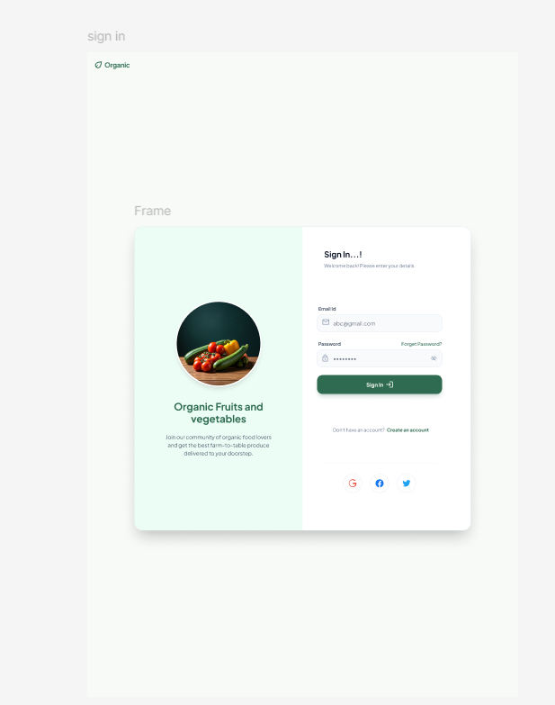

The Login Page is the secure entry point for registered users of the Organic Fruits and Vegetables Website. It allows users to authenticate themselves using their email address and password before accessing personalized features such as the wishlist, shopping cart, order history, and profile management. This page plays a crucial role in ensuring that only authorized users can access their account information and perform transactions securely.
The page is designed with a simple and user-friendly interface that enables users to log in quickly and efficiently. Proper validation mechanisms are implemented to verify user credentials and prevent unauthorized access. In case users forget their password, a password recovery option is provided to help them regain access to their account. New customers can easily navigate to the registration page and create an account if they have not previously registered.
The Login Page also contributes to enhancing the overall user experience by maintaining account security and protecting sensitive customer information. Once authenticated successfully, users can access personalized services, manage their orders, save favorite products, and enjoy a seamless shopping experience throughout the website.
Main Purpose:
Provide secure access to user accounts while protecting customer data and personal information.
Key Features:
- Email and password input fields.
- Secure user authentication process.
- Sign In button for account access.
- Forgot Password option for password recovery.
- Link to the Register Page for new users.
- Input validation and error messages for incorrect credentials.
- Protection against unauthorized account access.
- Responsive design for desktop and mobile devices.
User Benefits:
- Quick and secure access to personal accounts.
- Ability to manage orders, wishlist, and cart items.
- Safe storage of customer information.
- Convenient password recovery options.
- Personalized shopping experience based on user preferences.
- Improved security and privacy during online transactions.

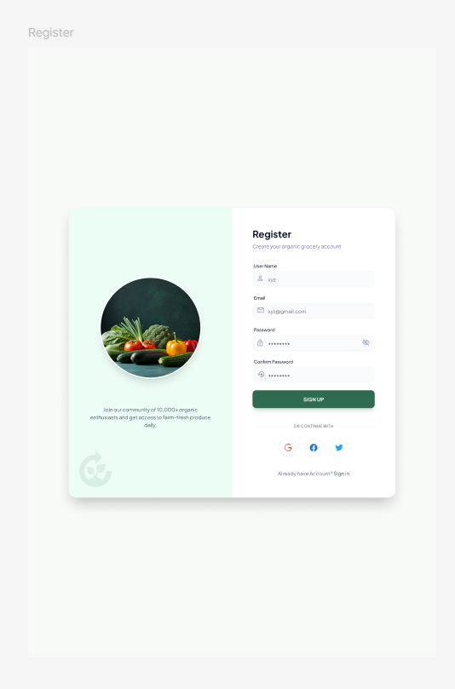

The Register Page allows new users to create an account and become registered members of the Organic Fruits and Vegetables Website. It serves as the first step for customers who want to access personalized features such as placing orders, managing their shopping cart, saving products to their wishlist, tracking order status, and maintaining their profile information. The registration process is designed to be simple, secure, and user-friendly, ensuring that users can create an account without any difficulty.
This page collects essential customer information, including name, email address, phone number, delivery address, and password. Validation mechanisms are implemented to ensure that all required fields are completed correctly and that the provided information is accurate. Password confirmation and security requirements help users create strong and secure passwords, protecting their accounts from unauthorized access.
Once the registration process is completed successfully, the user's information is securely stored in the system database, and a unique customer account is created. Registered users can then log in to the website and enjoy a personalized shopping experience. The Register Page plays an important role in building a customer database while ensuring the security and integrity of user information.
Main Purpose:
Collect customer information and create a secure user account that enables access to all website services and features.
Key Features:
- Fields for name, email address, phone number, address, and password.
- Password confirmation field for verification.
- Input validation to ensure accurate data entry.
- Secure password creation requirements.
- Agreement or consent checkbox for terms and conditions.
- Register/Submit button to create a new account.
- Prevention of duplicate account registrations.
- Responsive design compatible with multiple devices.
User Benefits:
- Easy account creation process.
- Access to personalized shopping features.
- Ability to place and track orders online.
- Save products in wishlist and shopping cart.
- Faster checkout process through stored information.
- Secure storage of personal and account details.
- Improved shopping experience through account-based services.

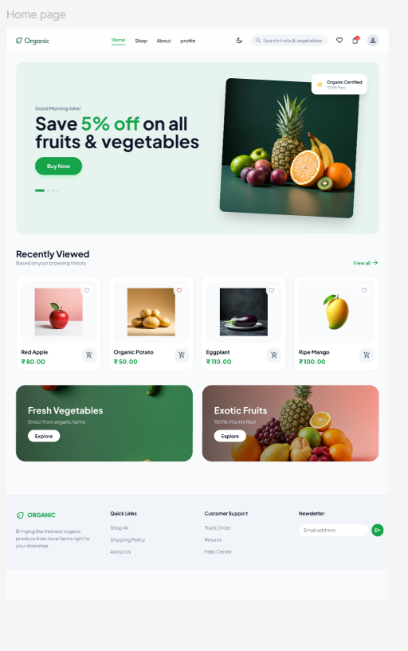

The Home Page serves as the main dashboard and landing page of the Organic Fruits and Vegetables Website. It is designed to provide users with an attractive and informative overview of the website while promoting fresh and organic products. As the first page users see after logging in, it creates a positive impression and encourages customers to explore the available products and services. The page is visually appealing, featuring high-quality images, promotional banners, and organized product sections that enhance user engagement.
The Home Page acts as a central navigation hub, allowing users to access important sections such as Shop, Wishlist, Cart, Orders, and Profile. It highlights featured products, seasonal fruits and vegetables, special discounts, and exclusive offers to attract customer attention and increase sales. A search bar is also provided to help users quickly locate specific products without browsing through multiple categories.
Additionally, the page emphasizes the benefits of organic farming and healthy eating by displaying organic certifications, quality assurances, and freshness guarantees. This helps build customer trust and confidence in the products offered. The well-structured layout ensures that users can easily browse products, discover new arrivals, and access important website features, resulting in a seamless and enjoyable shopping experience.
Main Purpose:
Showcase products, promotional offers, and important website sections while providing easy navigation for users.
Key Features:
- Navigation menu (Home, Shop, Wishlist, Cart, Orders, Profile).
- Search bar for quick product discovery.
- Promotional banners and seasonal discount offers.
- Featured and best-selling products.
- Categories for fruits, vegetables, and organic products.
- Organic certification and quality assurance highlights.
- New arrivals and recommended products section.
- Responsive design for mobile and desktop users.
User Benefits:
- Easy access to all website functionalities.
- Quick discovery of products and special offers.
- Convenient navigation between different sections.
- Better shopping experience through organized product displays.
- Access to fresh, certified organic products.
- Increased awareness of promotions and seasonal deals.
- Time-saving product search and browsing experience.

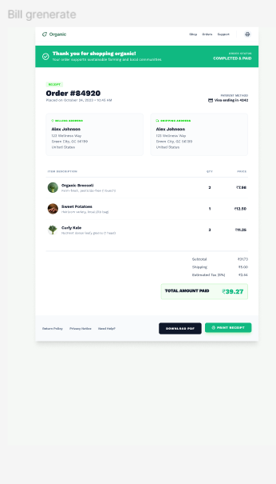

The Bill Generation Page is displayed after a customer successfully places an order and completes the payment process. Its primary function is to generate an official invoice that serves as proof of purchase for the transaction. This page provides a detailed summary of the order, ensuring transparency and accuracy in billing. It helps both customers and administrators maintain proper transaction records and simplifies future order verification.
The generated invoice contains important information such as customer details, order information, purchased products, quantity, unit prices, applicable taxes, shipping charges, and the final amount paid. Each invoice is assigned a unique invoice number and order ID for easy tracking and reference. The page is designed in a clear and organized format so that users can easily review all transaction details.
Additionally, the Bill Generation Page provides options to download, print, or save the invoice for future use. Customers can use the invoice for order tracking, returns, refunds, warranty claims, or customer support inquiries. By maintaining detailed billing records, the page improves transparency, builds customer trust, and ensures proper documentation of all purchases made through the website.
Main Purpose:
Generate a detailed and accurate invoice for completed orders and maintain an official billing record of the transaction.
Key Features:
- Displays customer information and delivery details.
- Generates a unique Order ID and Invoice Number.
- Provides an itemized list of purchased products.
- Shows quantity, unit price, subtotal, taxes, and shipping charges.
- Calculates the total payable and paid amount.
- Displays payment method and payment status.
- Download, print, and save invoice options.
- Clear and organized invoice layout for easy review.
User Benefits:
- Receives an official proof of purchase.
- Easy access to complete billing and order information.
- Can download or print invoices for future reference.
- Useful for returns, refunds, and customer support requests.
- Helps track expenses and maintain purchase records.
- Increases trust through transparent billing and payment details.
- Provides a secure and reliable transaction record.

